

**Proposal and Quotation for E-Commerce Seller Account Services**

https://www.veloxn.com

**Introduction -**

Thank You for showing interest in E-Commerce Seller Account Services with Veloxn Private Limited.

**Service Cost -**

The table below details the cost associated with this service.

|  |  |  |  |
| --- | --- | --- | --- |
| **Name** | **Unit Price** | **Months** | **Subtotal** |
| Amazon Seller account | ₹10,000 | 2 | ₹10,000 |
| After that rupees each product 4000 per Month |  |  |  |
| **TOTAL** |  |  | ₹10,000 |
| **GST @ 18%** |  |  | ₹1,800 |
| **TOTAL Including GST** |  |  | **₹11,800** |

Payment required is **₹11,800**

**Note\*** - Offer Valid for 7 Days only

**Bank Details**:

**VELOXN PRIVATE LIMITED**

AC Number – 259958439076

IFSC Code – INDB0000702

Bank Name – Indusind Bank

UPI ID - veloxnservices@okicici

QR Code – 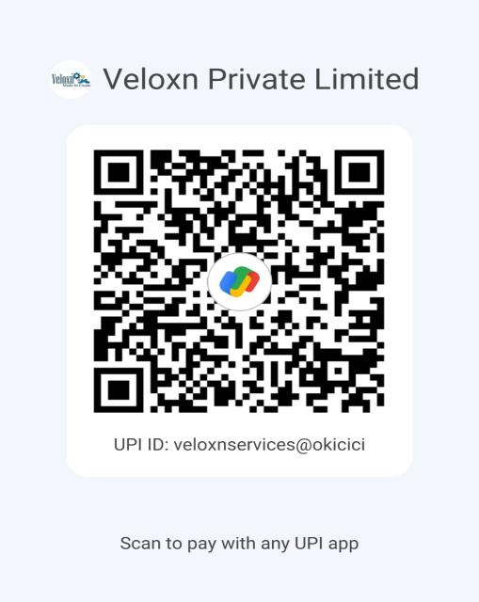

**COMPANY:**

Veloxn Private Limited

Iconic Tower C, Corenthum, Sector-62, Noida, UP - 201301, India www.veloxn.com

sales@veloxn.com

91-7292001010

GST - 06AAICV7138B1ZE